**Activity: Sorting and filtering a report**

**Introduction**

In this lesson on report navigation, you’ve gained insights into report hierarchies, drillthrough, sorting and filtering data, and cross-filtering and cross-highlighting. You will now have an opportunity to put some of your newly gained knowledge into action and apply it in a hands-on activity.

**Activity**

Your task is to open the given report and apply filtering and sorting to help the marketing stakeholders at Adventure Works make more informed data-driven decisions. To complete this activity, you need to:

* Open the existing marketing report in Power BI Desktop.
* Sort the ribbon chart in chronological order.
* Apply filters so that the ribbon chart and table chart display results for shipped orders only.
* Sort the line chart by the number of leads in ascending order.
* Sort the table and stacked column chart by region in ascending order.
* Make the stacked column chart and line chart display leads from Facebook and Google only.
* Display marketing data in the table for Facebook and Google only.
* Save the report for future use.

This screenshot that follows provides a visual representation of what your report will look like after successfully completing the tasks outlined in this activity.

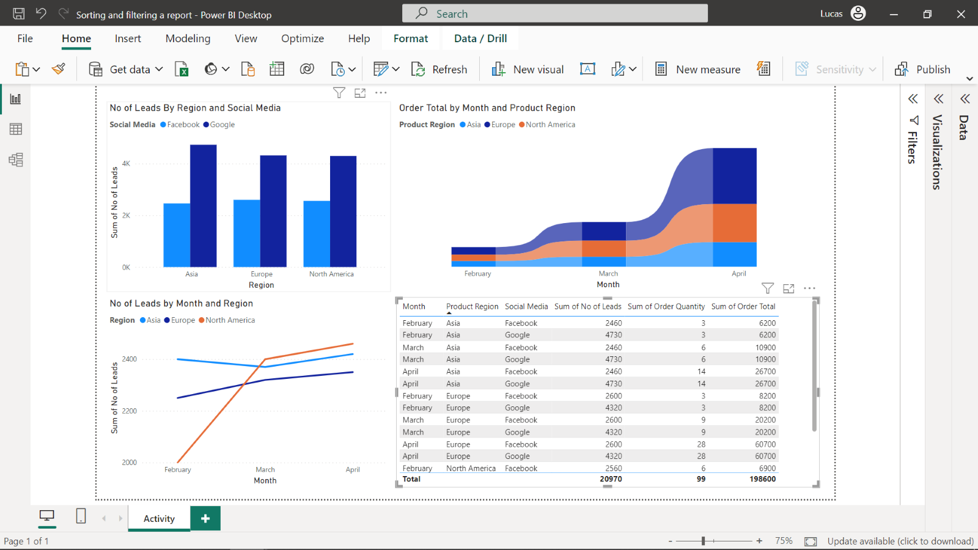

**Instructions**

Before starting the activity, you need to download the existing Power BI report from the marketing team at Adventure Works, *Sorting and filtering a report.*

[Sorting and filtering a report](https://d3c33hcgiwev3.cloudfront.net/18UQLQ2ZTcml9P7PxEMsvA_0b2299cfb8b044b08bee058dbfe1c3e1_Sorting-and-filtering-a-report.pbix?Expires=1711324800&Signature=GnFJEr35PU8IZUFztnnLPsR0qu8OIhT20JE-hQpj7DEqhlBaEx6sfHipJP0acOM4XBywbwvxXtkqjiphqOhGYnEISxuN7zSph-iY-l1sPdTzld1TuzBBknC0KjmSqBlpbzczt6tJqCvpMYutanjqYPL1UFNbhTmCb-lnx8UL-D4_&Key-Pair-Id=APKAJLTNE6QMUY6HBC5A" \t "_blank)

[PBIX File](https://d3c33hcgiwev3.cloudfront.net/18UQLQ2ZTcml9P7PxEMsvA_0b2299cfb8b044b08bee058dbfe1c3e1_Sorting-and-filtering-a-report.pbix?Expires=1711324800&Signature=GnFJEr35PU8IZUFztnnLPsR0qu8OIhT20JE-hQpj7DEqhlBaEx6sfHipJP0acOM4XBywbwvxXtkqjiphqOhGYnEISxuN7zSph-iY-l1sPdTzld1TuzBBknC0KjmSqBlpbzczt6tJqCvpMYutanjqYPL1UFNbhTmCb-lnx8UL-D4_&Key-Pair-Id=APKAJLTNE6QMUY6HBC5A" \t "_blank)

**Step 1: Open the report file in Power BI Desktop.**

* Select the **File** menu, followed by **Open Report** and the *Sorting and filtering a report* file.

**Step 2: Sort the ribbon chart in chronological order**

1. Select the ribbon chart, then the three dots on the top right corner of the visual.
2. Select **Sort axis**, then **Month**, then **Sort ascending**.

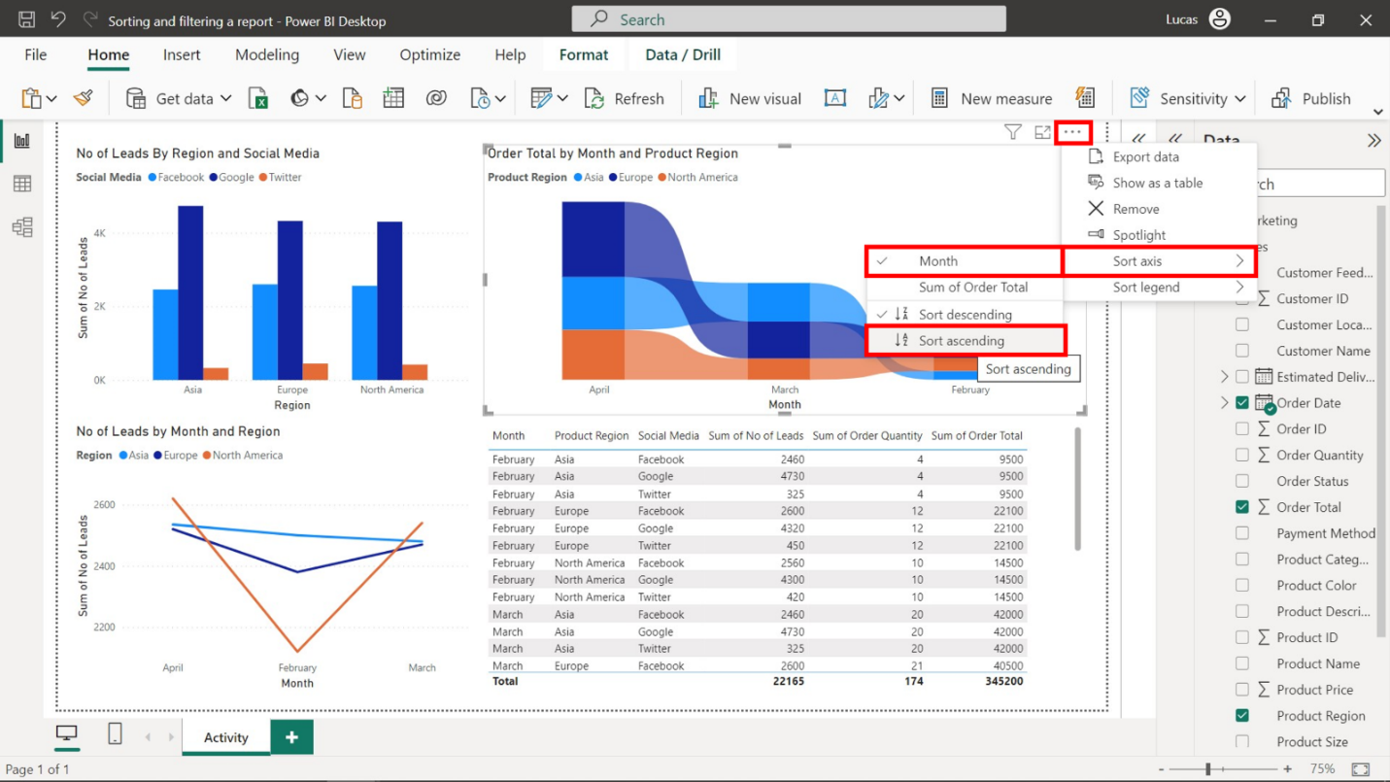

**Step 3: Apply filters so the ribbon and table charts display results for shipped orders only.**

1. Select the ribbon chart and open the **Filters** pane.
2. Drag the **Order Status** field from the **Data** pane to the **Add data fields here** box in the **Filters on this visual** section.
3. Check **Shipped** in the **Order Status** filter.

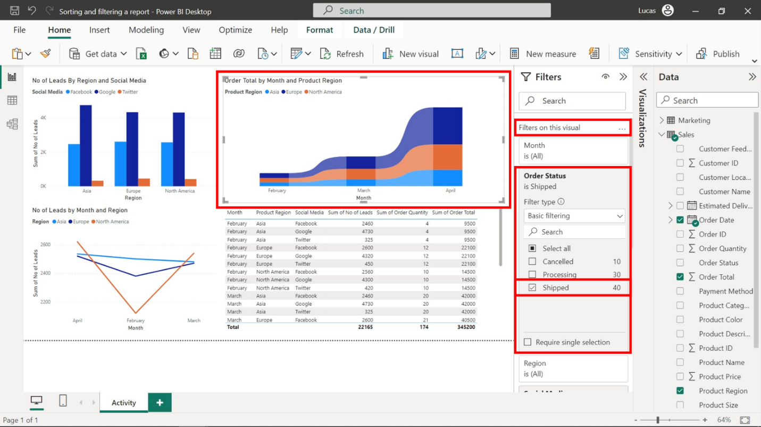

1. Select the table chart and open the **Filters** pane.
2. Apply the same process to the table chart.

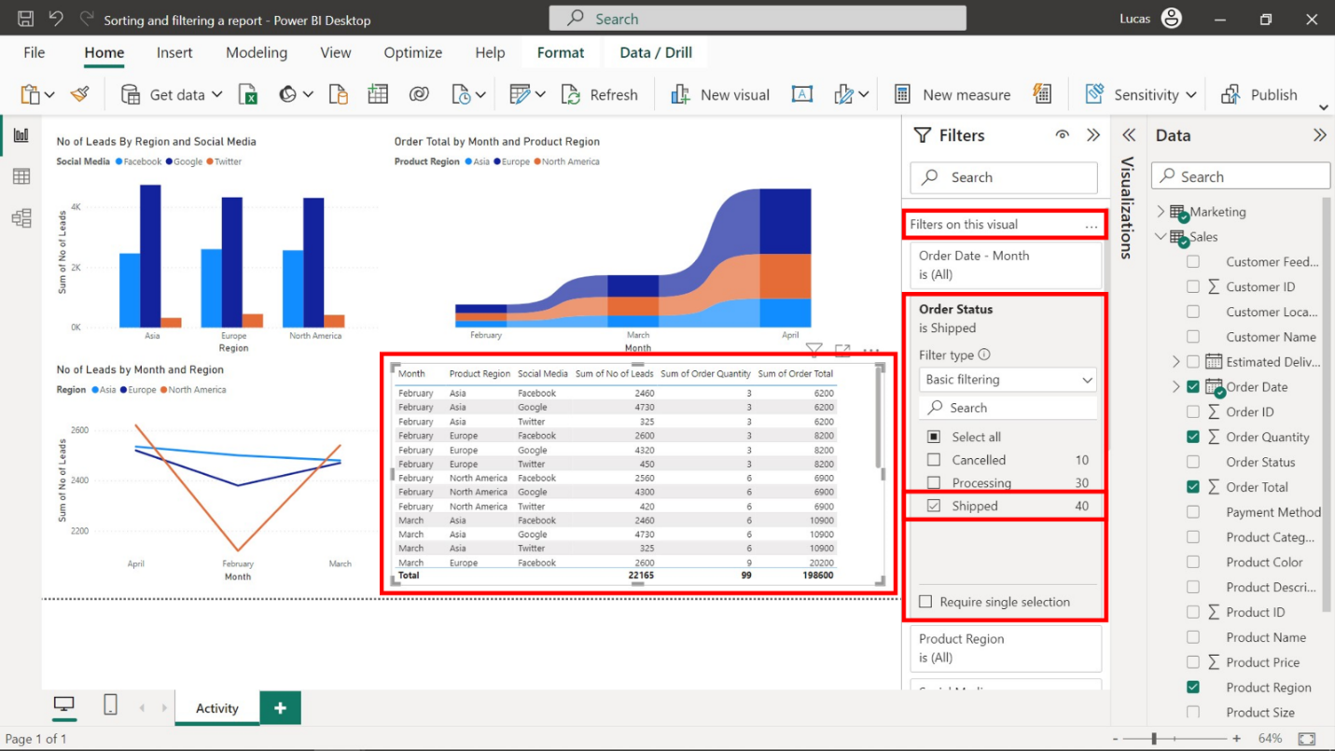

**Step 4: Sort the line chart by no of leads in ascending order.**

1. Select the line chart and then the three dots in the top right corner of the visual.
2. Select **Sort axis**, then **Sum of No of Leads**, then **Sort ascending**.

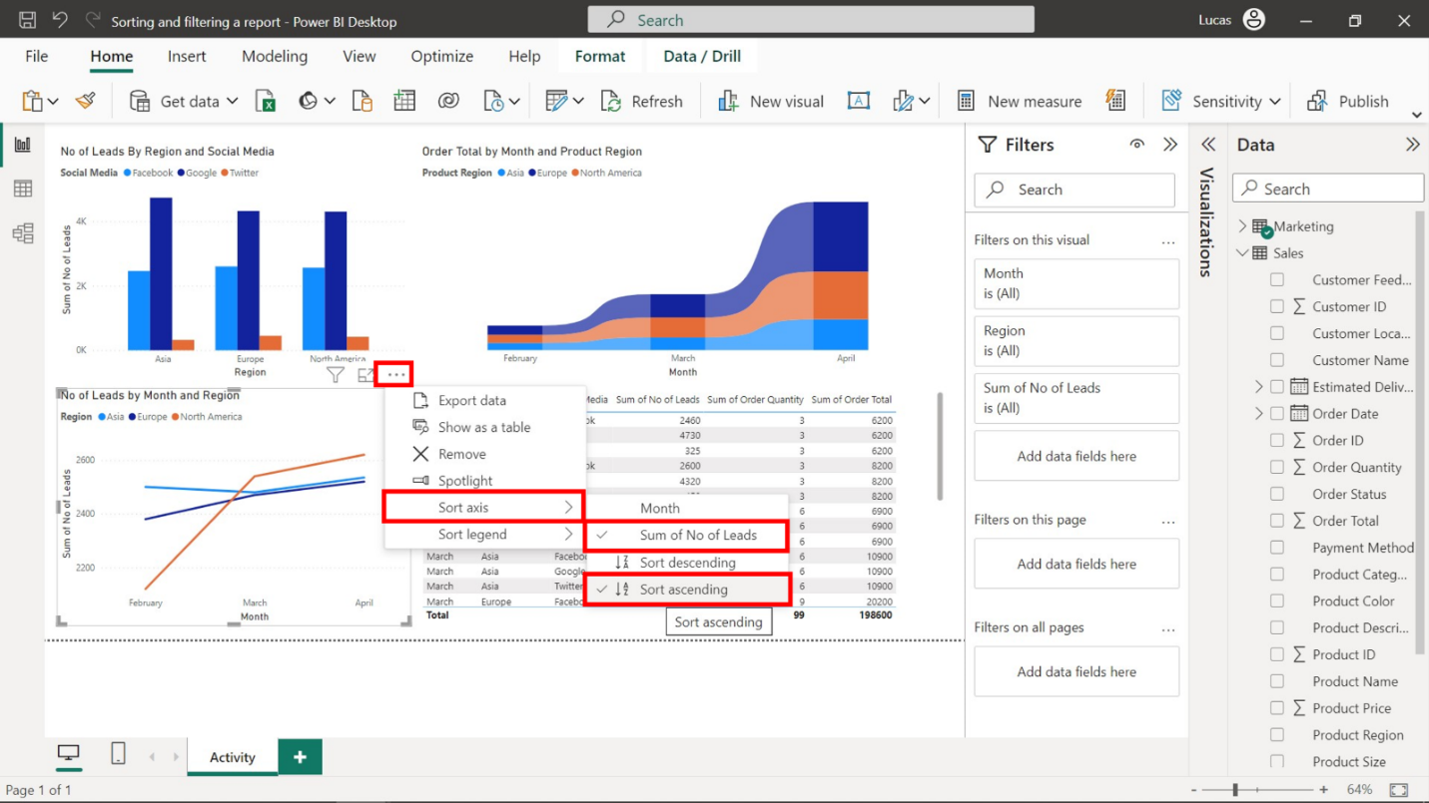

**Step 5: Sort the table and stacked column chart by regions in ascending order.**

1. Select the stacked column chart, followed by the three dots in the top right corner of the visual.
2. Select **Sort axis**, then **Region**, then **Sort ascending**.

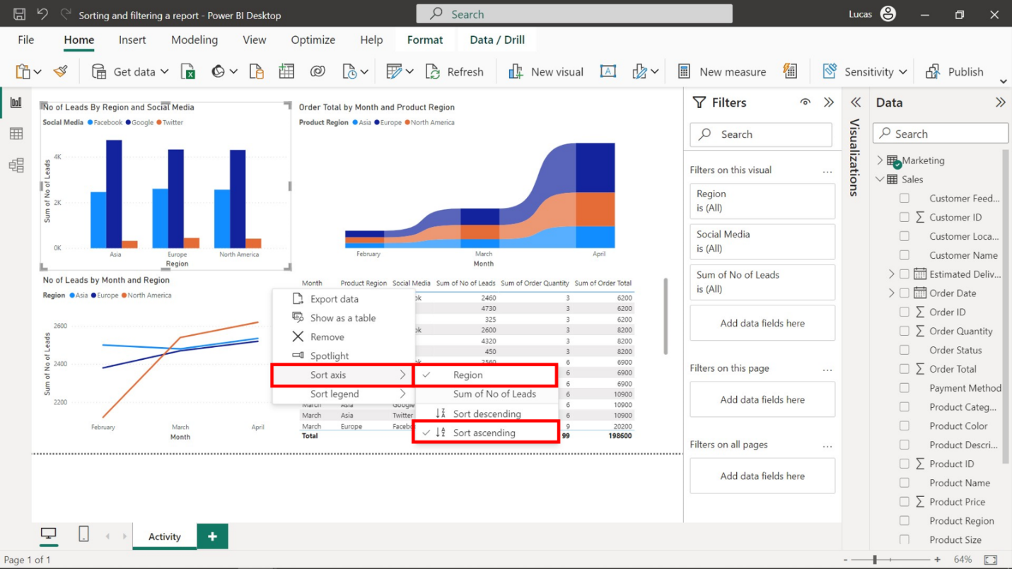

1. Next, select the table visual, then the **Product Region** column title. Make sure the arrow sign under this column title is pointing upward.

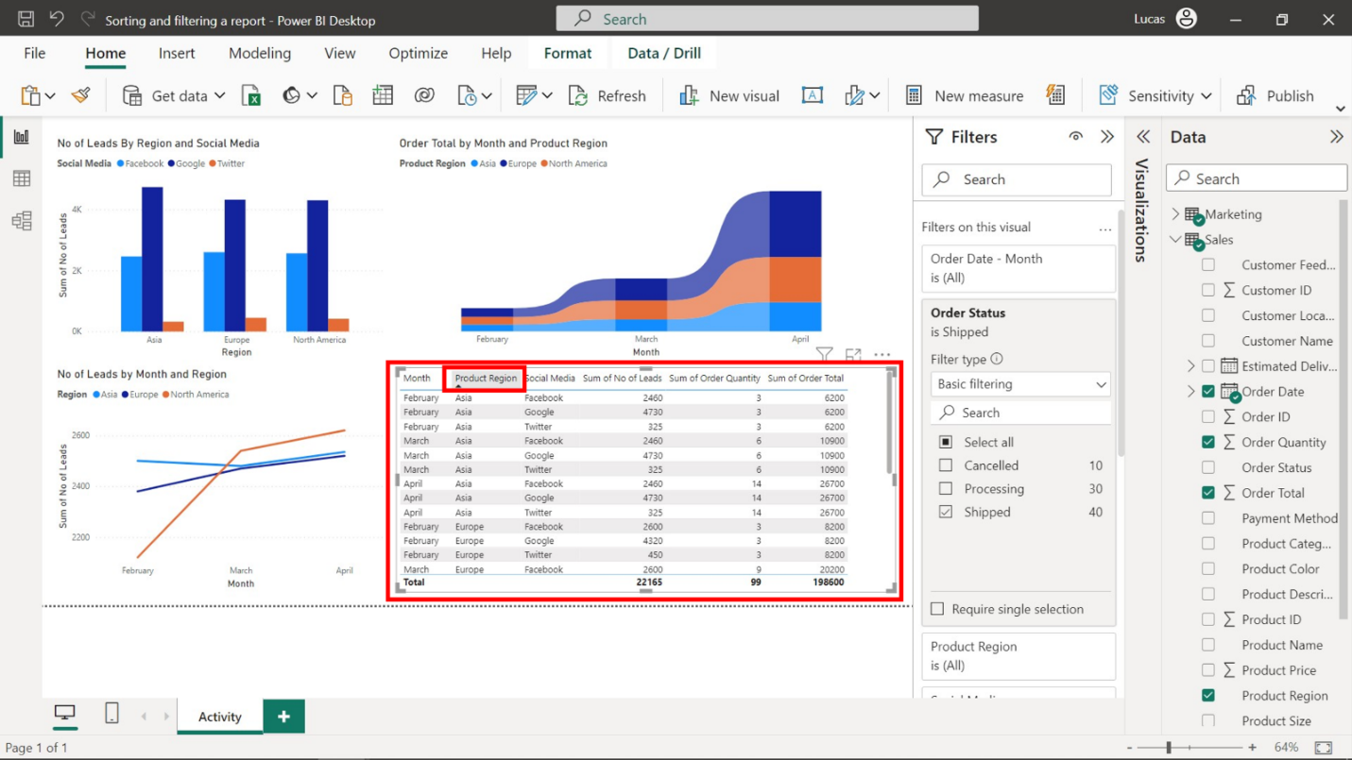

**Step 6: Filter the stacked column and line charts to display leads from Facebook and Google only.**

1. Select the stacked column chart and open the **Filters** pane
2. Drag the **Social Media** field from the **Data** pane to the **Add data fields** here box in the **Filters on this visual** section.
3. Check **Google** and **Facebook** only.

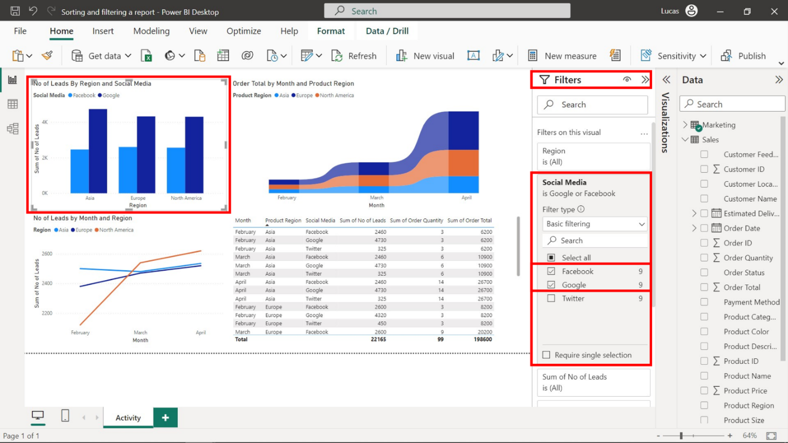

1. Select the line chart and open the **Filters** pane.
2. Apply the same process to the line chart.

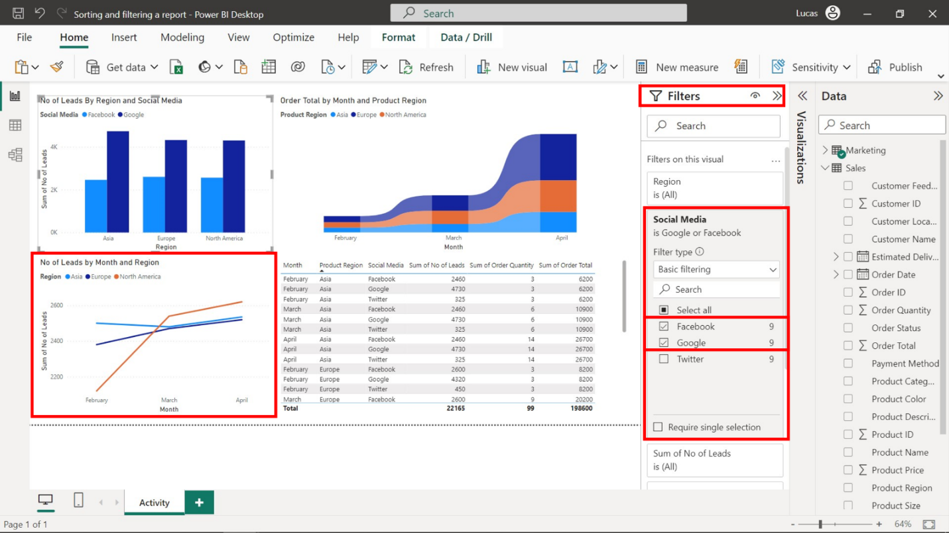

**Step 7: Display marketing data in the table for Facebook and Google only.**

1. Select the table visual and open the **Filter** pane.
2. Drag the **Social Media** field from the **Data** pane to the **Add data fields here** box in the **Filters on this visual** section.
3. Check **Google** and **Facebook** only.

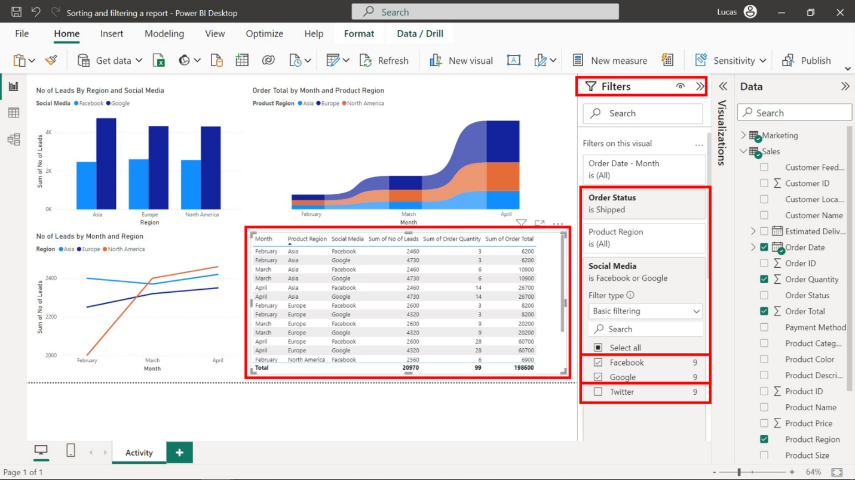

**Step 8: Save the report for future use**

* Once all the changes have been made, save the report by opening **File** menu and selecting **Save**.

**Conclusion**

By completing this activity, you have gained insight into the impact and importance of sorting, filtering, and refining data within a report for driving informed decision-making. By practicing using and applying report navigation techniques like sorting and filtering in Power BI, you will become increasingly proficient at shaping data into meaningful insights for stakeholders.

**Exemplar: Creating an interactive report**

**Introduction**

In the exercise *Creating an interactive report,* you were asked to build an interactive report that allowed viewers to drillthrough the data hierarchy based on month and navigate report pages using buttons and bookmarks.

Your task in this exercise was to:

* Create a new report page and configure the drillthrough for the sales month
* Add a slicer to filter by product category
* Create a bookmark for mountain bikes sold in March

This reading provides you with a step-by-step guide for completing these steps. It also includes screenshots that you can compare against your work.

**Step 1: Create the Sales Detail page**

1. Download the *Creating an interactive report.pbix* file and open it in Power BI. The **Q1 Sales Summary** page will be displayed.

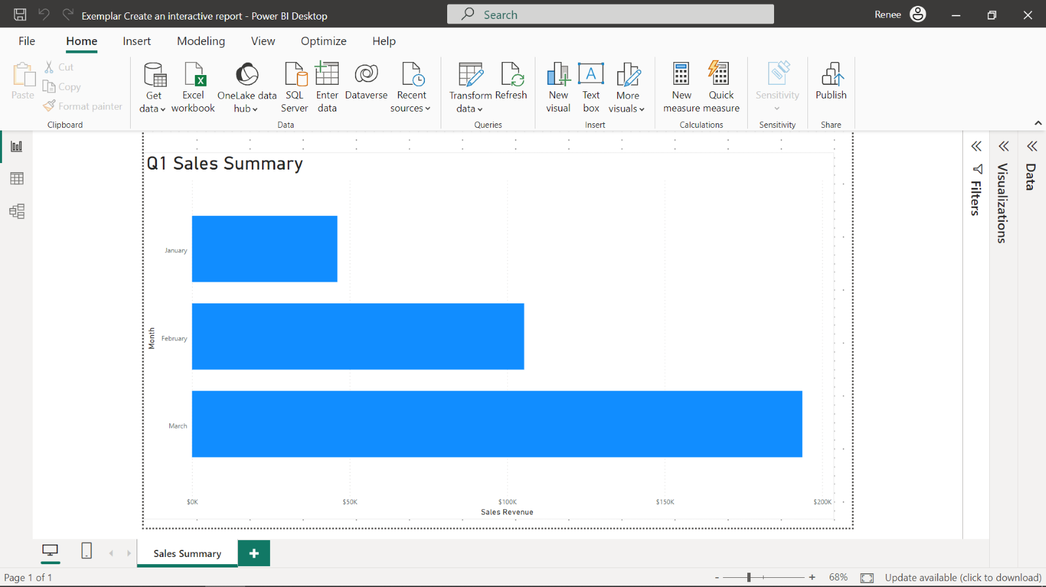

1. Select the **Plus** icon beside the **Sales Summary** tab to create a new report page. Name the report page **Sales Detail**.

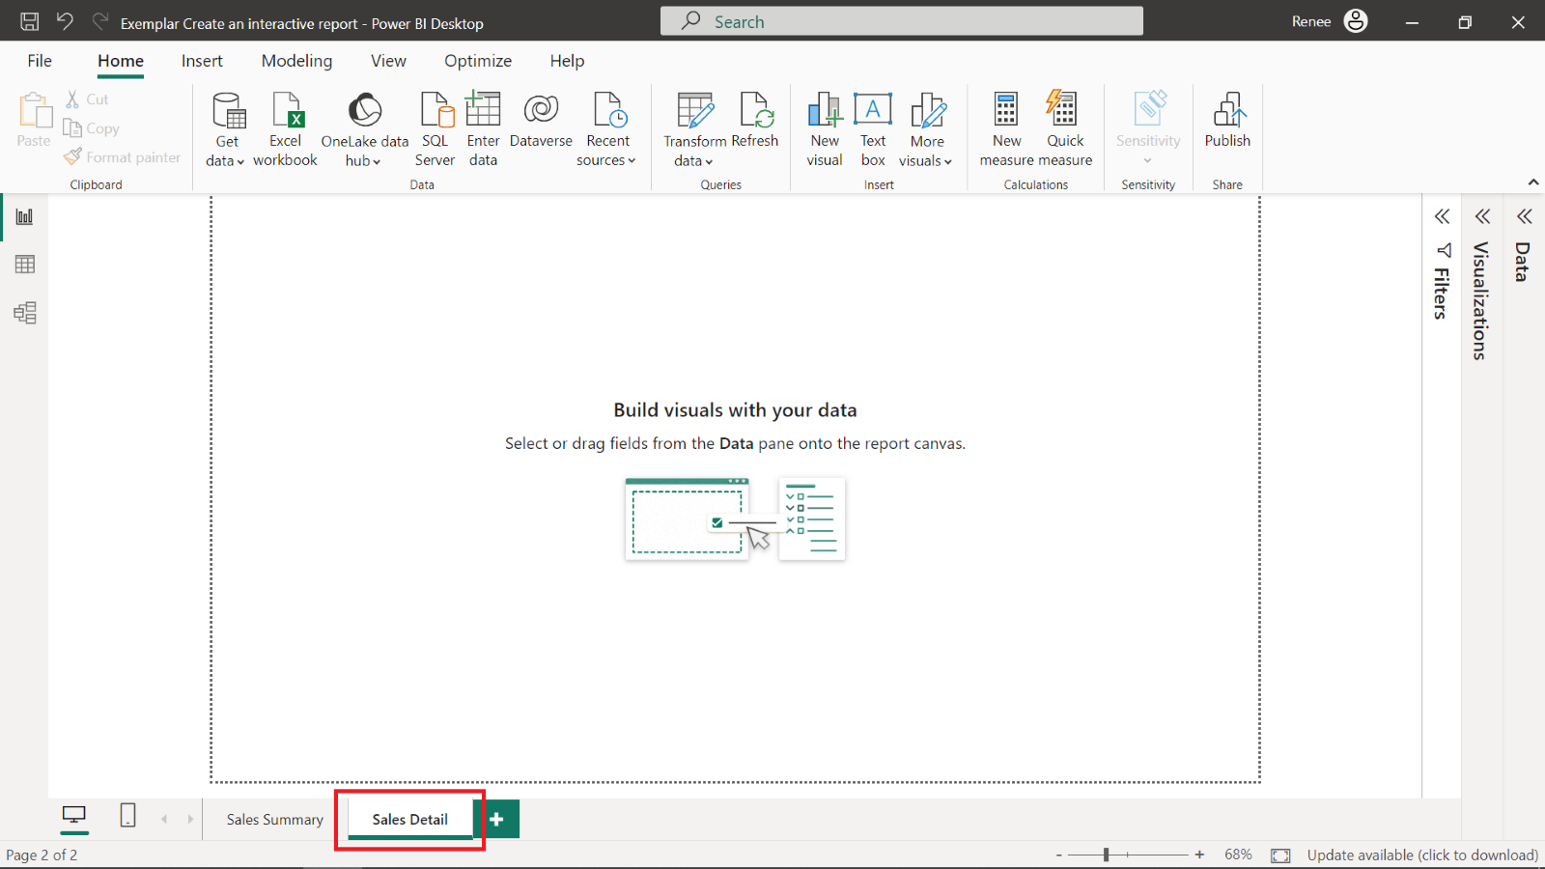

1. Add a table visualization containing a summary of sales revenue per customer location.

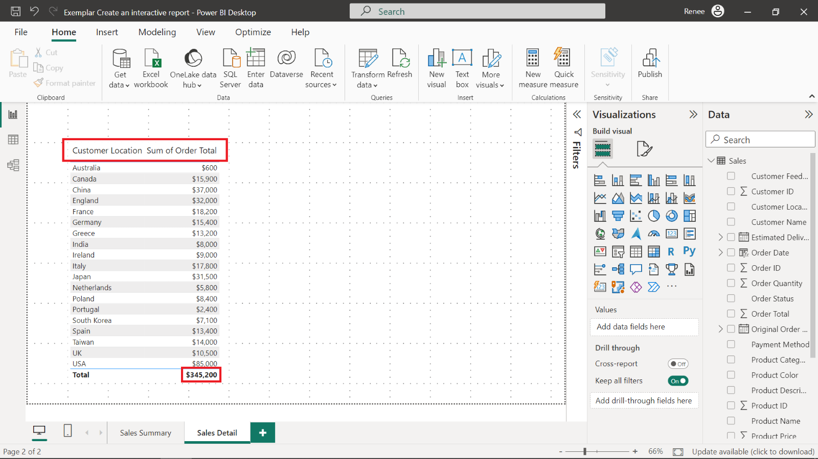

1. The **Total** sales revenue is displayed as $345,200 in the summary row at the bottom of the table.

**Step 2: Connect the order Month as the Drillthrough field**

1. Open the Data pane and expand the **Order Date** field in the **Data** pane.
2. Drag the **Month** field from the **Data Hierarchy** to the **Drillthrough** field of the table.

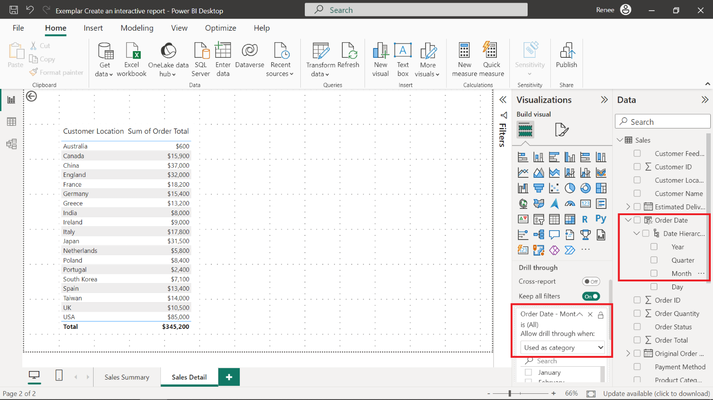

Power BI automatically creates a **back arrow** button in the top-left corner of the report page. Holding the **control** key and selecting the **back arrow** button will navigate to the **Sales Summary** page.

**Step 3: Add a slicer for Product Category**

1. Open the **Sales Summary** page.
2. Add a slicer visualization and select **Product Category** as the filter field.

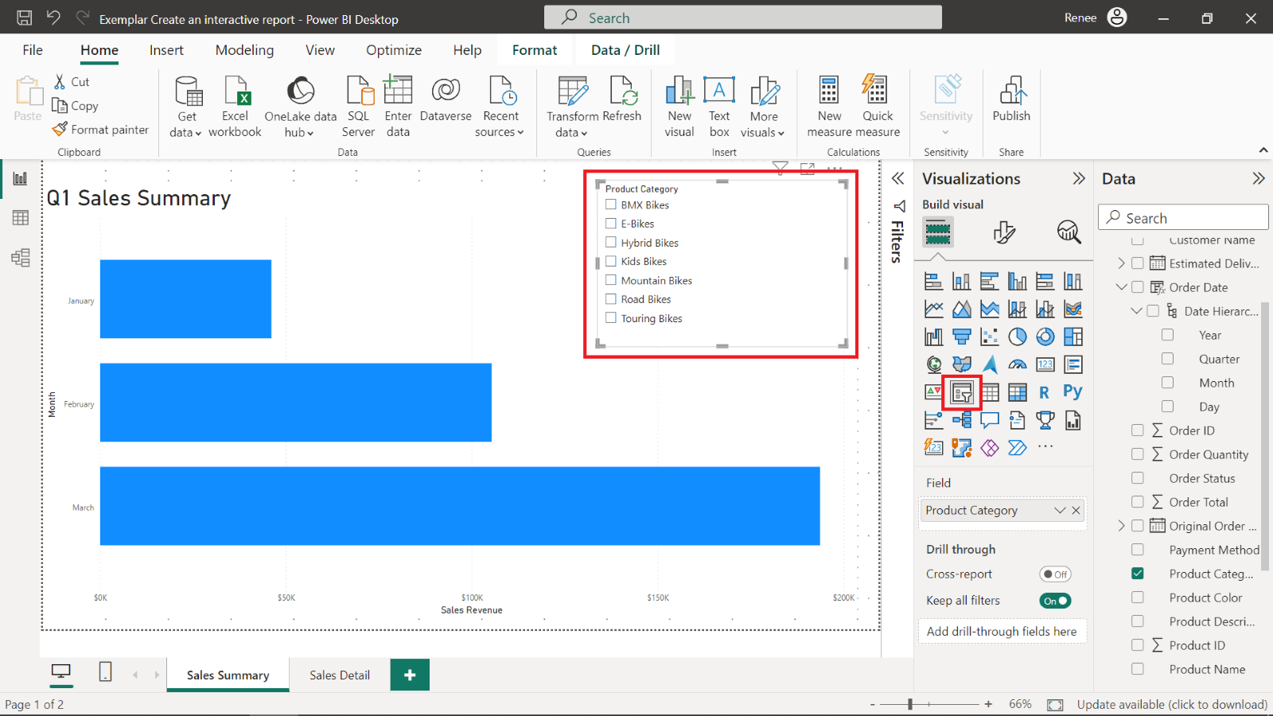

**Step 4: Add a bookmark for Mountain Bikes sold in March**

1. Select **Mountain Bikes** in the slicer to filter the data to only sales in the **Mountain Bike** product category.

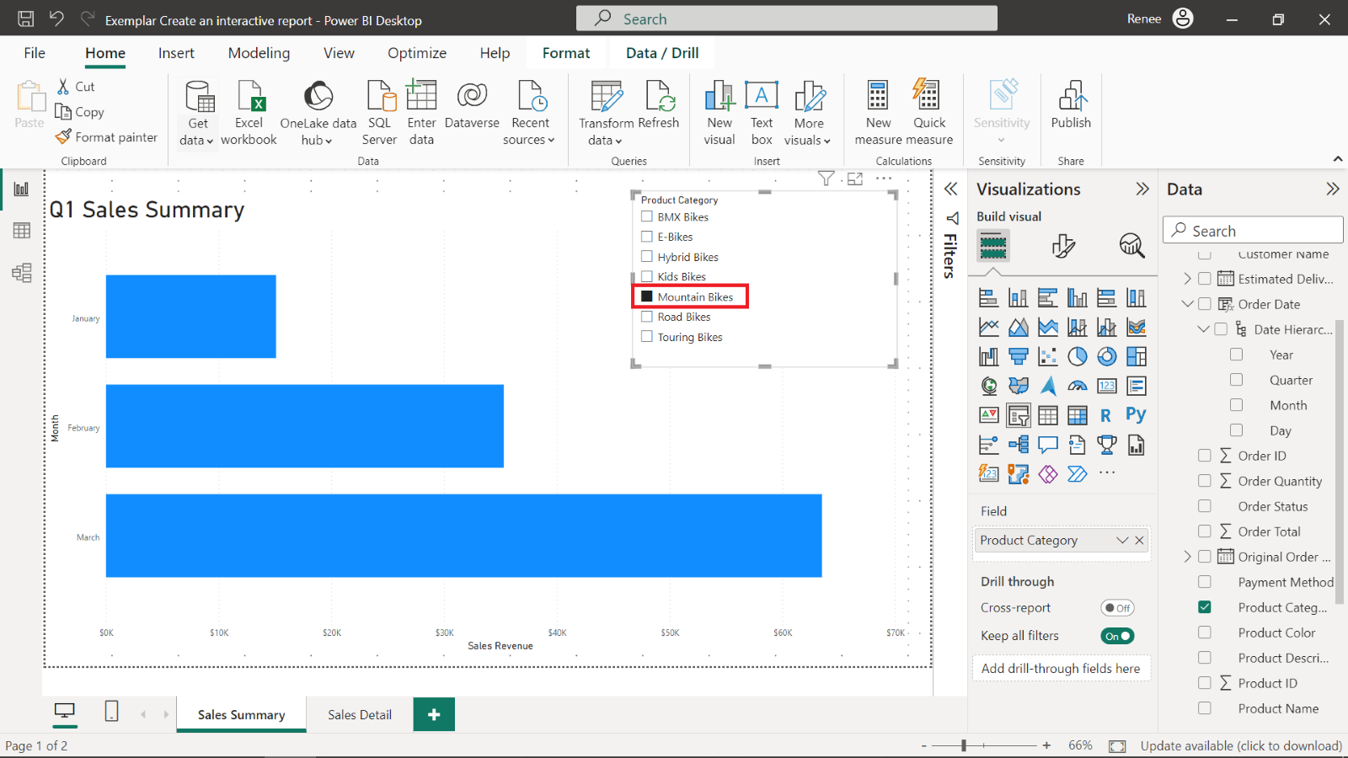

1. Right-click the **March** column, select **Drill through** and then **Sales Detail**.

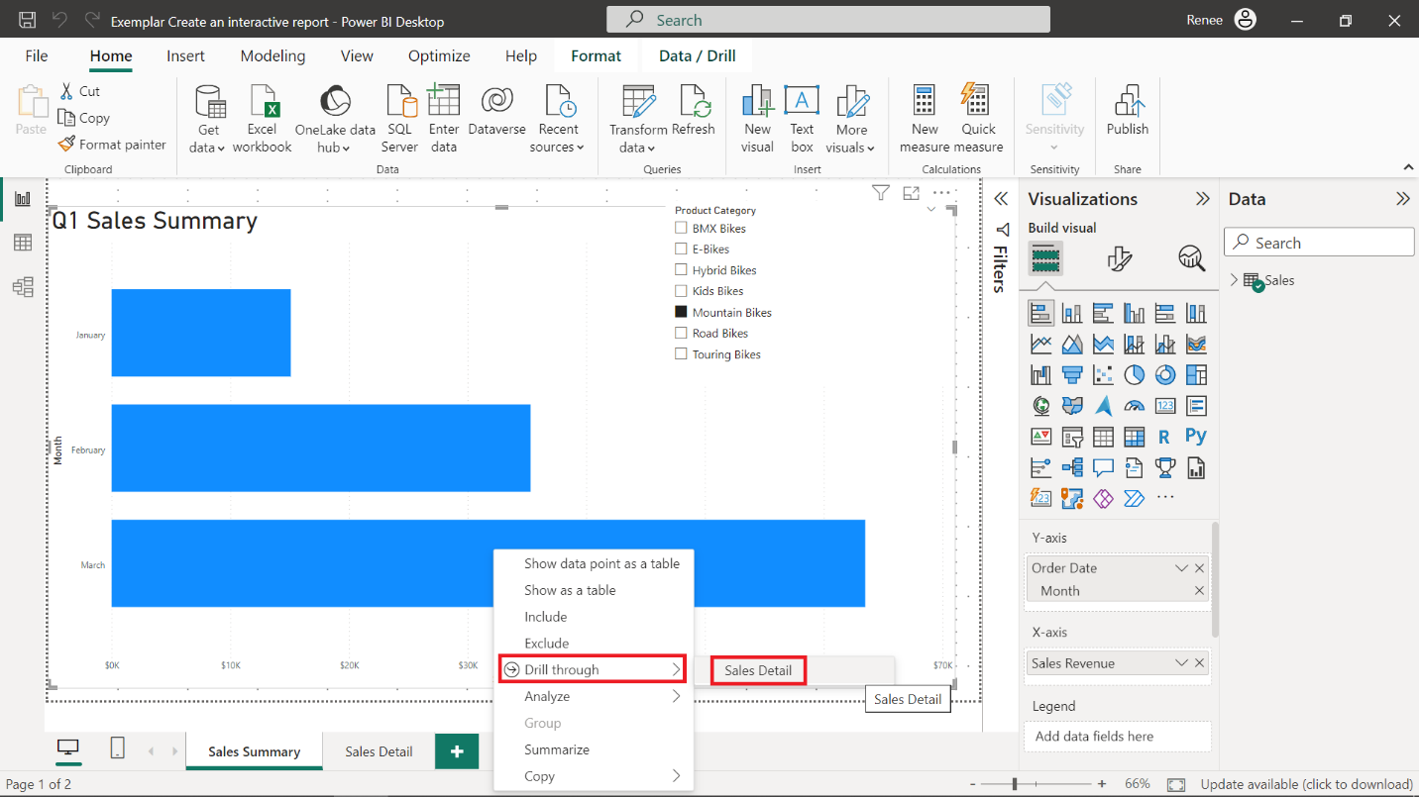

1. Navigate to the **View** tab in the Ribbon and select **Bookmarks**. In the **Bookmarks** pane, select **Add** to add a new bookmark and rename it **March Mountain Bikes Revenue.**

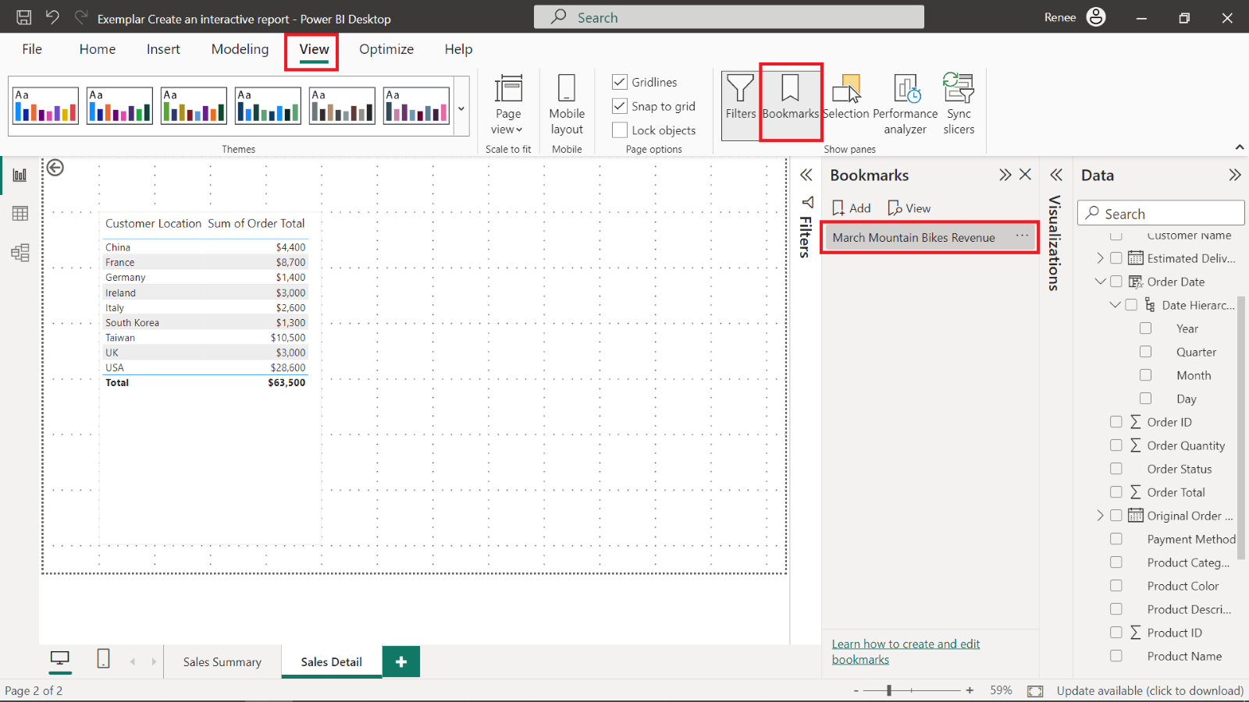

1. Select the bookmark to restore the filtered state. The **Total** sales revenue is $63,500 in the **Sales Detail** page.

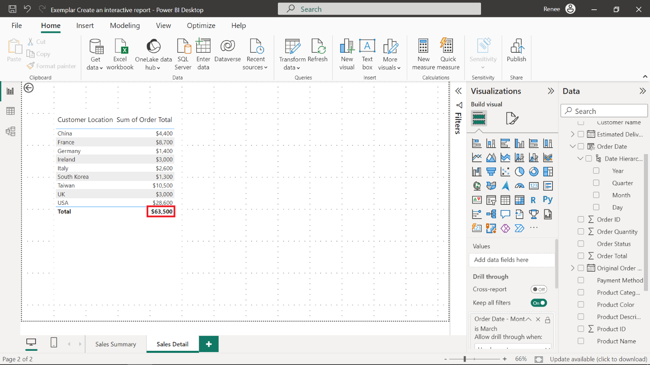

**Conclusion**

Congratulations! You have successfully completed this exercise. By adding the drillthrough, button, slicer, and bookmark features to the Power BI report, you've elevated it by making it more interactive and engaging. These tools give you the power to deliver valuable insights and create a smoother experience for your audience. As you keep working on your reports, these skills will be a valuable asset, helping you create more impactful, interactive, and user-friendly presentations.